The Power of Selling
Instructor Manual

Planning Your Course

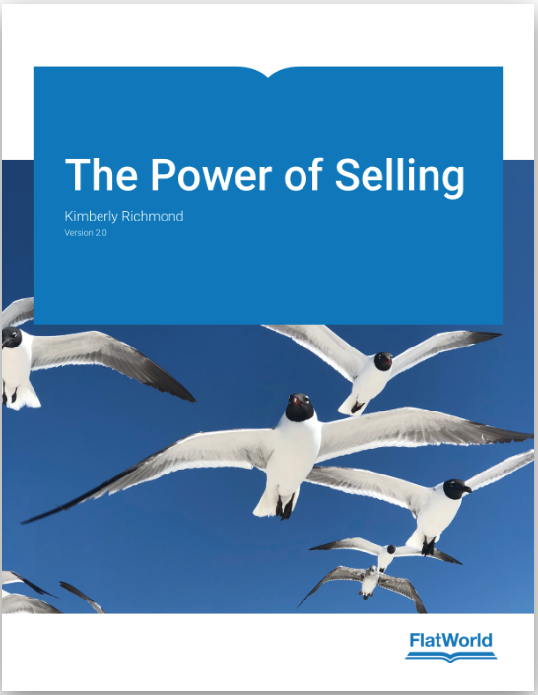

Table of Contents

Introduction | 2
Textbook Features and Resources  Planning Your Class | 2  4
Sample Course Schedule—16-week class | 4
Sample Course Schedule—10-week class | 5
Individual Project—LinkedIn | 8
Capstone Team Project—Sales Shark Tank | 9

Introduction

Dear Educator,

Welcome to The Power of Selling, v2.0.

This textbook is a journey designed to help students understand and apply the principles of selling. And, whether they pursue a career in professional sales or choose a different career path, this textbook will help them prepare for the real world and help them create and build their personal brand.

This textbook can be used for any class that includes a focus on selling and/or personal branding, including Personal Selling, Salesmanship, Sales, Professional Selling, Personal Branding and Professional Development. The book has all the basics so it can easily be used with freshman and sophomores, yet it is challenging enough to use in upper level classes with juniors and seniors. All students will benefit from the extensive professional selling and personal branding information.

The flow of the textbook is such that Chapters 1–7 are foundational topics such as overview of personal selling, careers in sales, relationships and networking, communications, ethics, social selling. The second half of the book, Chapters 8–14, includes a chapter dedicated to each one of the seven steps of the selling process. The final chapter focuses on entrepreneurial selling and includes resources for those that might want to start their own business.

This Instructor Manual provides ideas and resources for class activities, assignments and projects with a focus on hands-on application and real-world experiences. The recommended course schedule, individual LinkedIn project, and Capstone Team Project, VoiceThread/discussion board assignments and individual assignments have all been used in a Personal Selling class so they are classroom tested.

Have a great semester!

Kim Richmond
Author, The Power of Selling

Textbook Features and Resources
The Power of Selling, v2 includes several features that make the textbook interesting for students to learn and easy to adopt and use. Here is a summary of the key features:

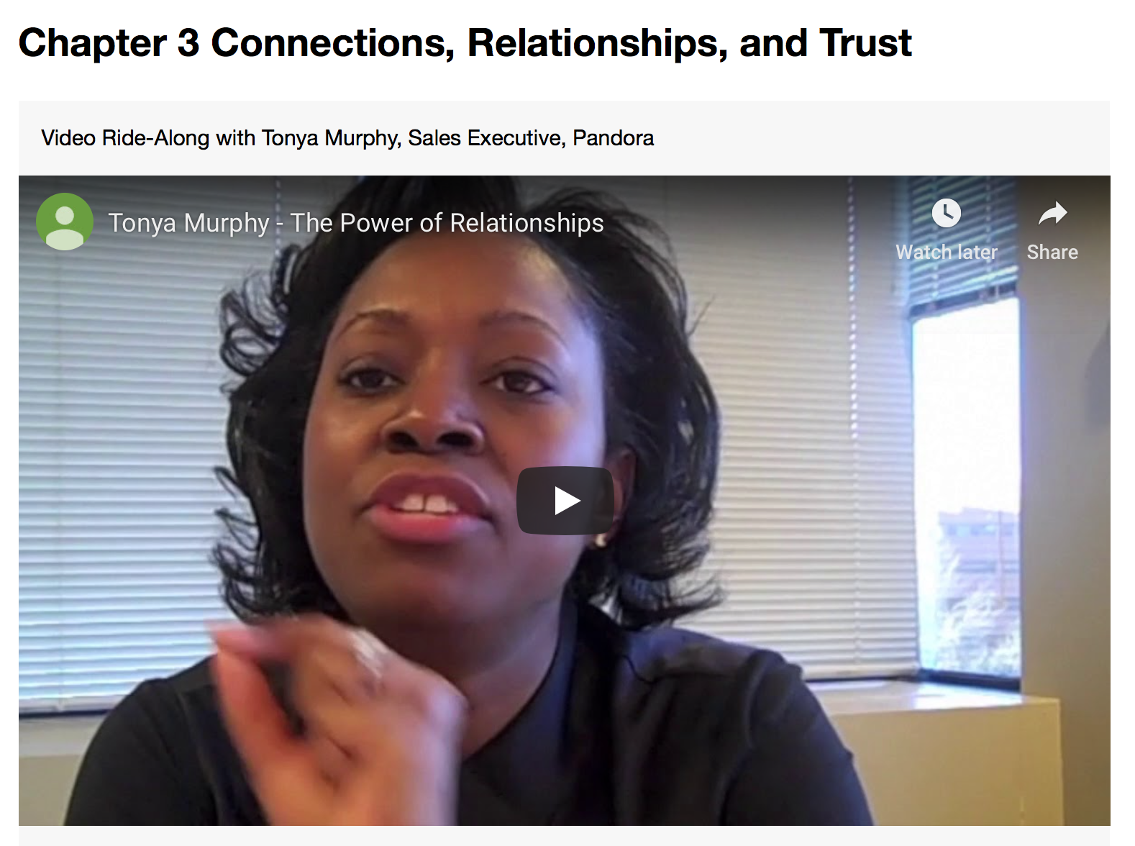
Video Ride-Alongs
Each chapter begins with a short video (1–3 minutes) that features a sales professional discussing a key concept in the chapter. The best way to learn about selling is to ride along with a seasoned professional. The Video Ride-Alongs bring the real world into the classroom. And, they provide an excellent platform for class discussions. There are additional short videos from the sales professional throughout the chapters.

Power Player: Lessons in Selling From Successful Salespeople
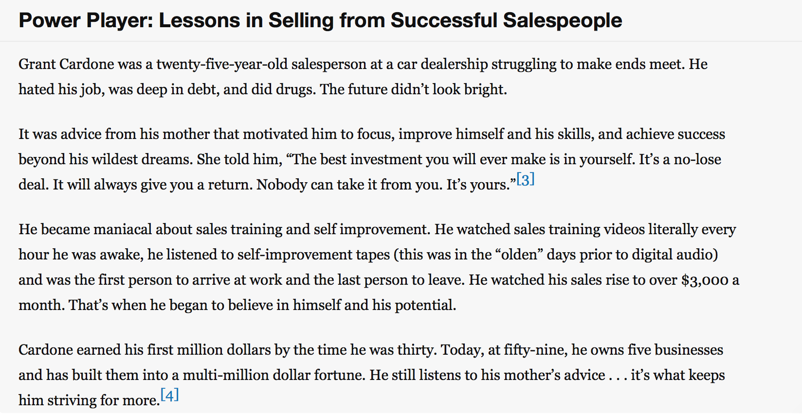
Sales professionals are highlighted throughout the book with stories that highlight how they achieved success. These vignettes are motivational and reveal the challenges and triumphs of selling.

This feature provides a framework for discussions in class as well as reflective assignments.

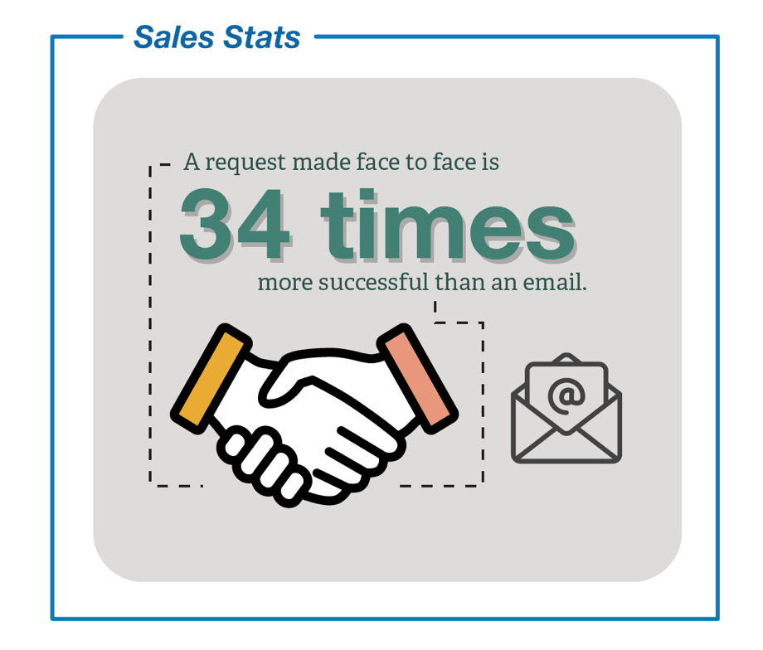
Sales Stats
This new feature highlights powerful statistics about selling and translates them into mini infographics. The format makes it easy for students to learn about the scope and impact of sales. The Sales Stats infographics are also included in the PowerPoint slides in each chapter.

Well Said: Inspirational Quotes about Successful Selling
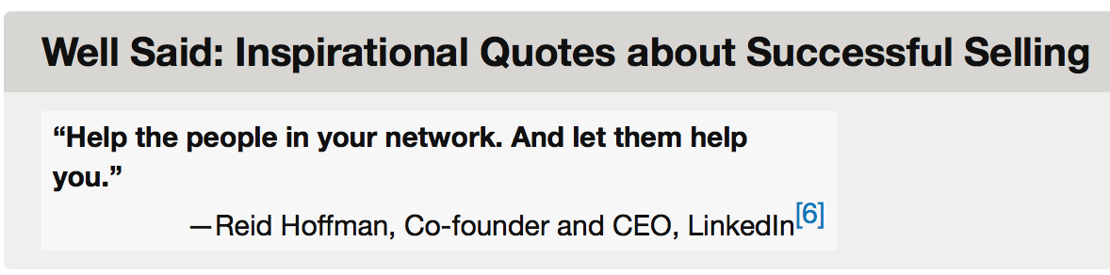
Leaders and prominent people in the sales community provide interesting insights with these pithy quotes that are scattered throughout the book.

Selling U
The final section of each chapter is titled Selling U. It translates the concepts covered in the chapter into a personal branding primer. What better place to learn about the concept of developing a personal brand than in a personal selling textbook? Topics range from the description and definition of a personal brand to resumes and cover letters, networking, interviewing, negotiating and accepting the right job offer and leveraging LinkedIn for a job search.

The Power of Selling LinkedIn Group
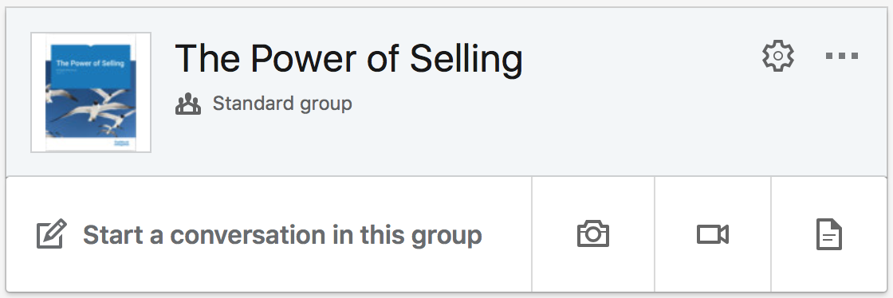
The impact of social media is undeniable in every discipline, but especially in sales. That’s why Chapter 6—#SocialSelling: Adding Value to Your Network is dedicated to the use of social media to connect with prospects and prospective employers. The group is comprised of thousands of sales professionals, educators and students who share articles, information and insights. You’ll see that participation in the group is included in the recommended LinkedIn individual semester project. Feel free to pose questions in the group and encourage your students to do the same.

Planning Your Class
Before you get down to the details, it’s a good idea to think about the end of the semester and what you want students to learn as a result of this experience. Then, consider the workload, for the students and yourself. Because selling is an interactive and hands-on discipline, consider the balance between individual work/assignments and team work/assignments.

This Overview provides sample syllabi (10-week and 16-week courses) along with suggestions and ideas for individual and team assignments and projects. These are resources that are designed to make it easy to adapt and adjust for your situation.

Sample Course Schedule—16-week class
Following is a suggested syllabus for a 16-week class. It assumes two class meetings per week and can be easily adjusted for a different class meeting schedule.

It includes:
- The Power of Selling reading
- Two exams—Mid-term and Final
- Four individual voice-recorded assignments (using a tool such as VoiceThread)
- Two individual written homework assignments (related to the Capstone Team Project)
- One individual project (LinkedIn)
- Capstone Team Project—Sales Shark Tank (including two team “progress” assignments related to this project)

The LinkedIn and Capstone Team Project—Sales Shark Tank projects are outlined after the sample course schedules. The other assignments are included in the appropriate chapter of the Instructor Manual.

This schedule assumes that the Capstone Team Presentations take place during the Final Exam period. The Final Exam is given prior to the end of the semester to allow rehearsal time for the presentations. This can be easily adjusted to do the presentations prior to the Final Exam.

Course Schedule – 16-week class
Week | Reading – The Power of Selling | Capstone Team Project Sales Team Assignments | Individual Assignments | Exams
1 | Chapter 1 – The Secret to Success in Life | - | Elevator Pitch VoiceThread | -
2 | Chapter 2 – Exploring Careers in Sales  Chapter 3 – Connections, Relationships, and Trust | Sales Team Choices and Sales Team Names | - | -
3 | Chapter 4 – Difficult Choices: Doing the Right Thing  Chapter 5 – The Ultimate Guide to Communication and Etiquette | Sales Team Products/Services due | - | -
4 | Chapter 6 – #SocialSelling: Adding Value to Your Network | - | LinkedIn, Part 1 | -
5 | Chapter 7 – Why and How Customers Buy | Product Details – Situation Analysis, SWOT + Persona | - | -
6 | Chapter 8 – The Foundation of the Selling Process: Prospecting and Qualifying | - | Prospecting and Qualifying | -
7 | Chapter 9 – Preparing for Success: The Pre-Approach | - | Pre-approach – Prospect Discovery | Mid-term Exam
8 | Chapter 10 – The Moment of Truth: The Approach | - | Approach VoiceThread  LinkedIn, Part 2 | -
9 | Spring/Fall Break – no class |  | - | -
10 | Chapter 11 – Present Like a Pro: The Presentation | Sales Proposal Draft Due | - | -
11 | Chapter 12 – Anticipating Opportunities: Handling Objections | Sales Meetings – Proposal Draft Review | Handling Objections VoiceThread | -
12 | Chapter 13 – Asking for the Sale: The Close | - | Closing VoiceThread | -
13 | Chapter 14 – Doing It Right: The Follow-up  Chapter 15 – So You Want to Be an Entrepreneur | - | LinkedIn, Part 3 | -
14 | Big Idea Sales Meetings (meeting with each team to review their ideas for the Capstone Team presentation)  Final Exam | Sales Meetings – Big Ideas | - | Final Exam
15 | Presentation Requirements and Tips  Presentation Rehearsal | Final Sales Proposal due  Peer Evaluation due | - | -
Final Exam Time | Capstone Team Presentations | Final Sales Presentation + Presentation due | - | -

Sample Course Schedule—10-week class
Following is a suggested syllabus for a 10-week class. It assumes two class meetings per week and can be easily adjusted for a different class meeting schedule.

It includes:
- The Power of Selling reading
- Two exams—Mid-term and Final
- Four individual voice-recorded assignments (using a tool such as VoiceThread)
- Two individual written homework assignments (related to the Capstone Team Project)
- One individual project (LinkedIn)
- Capstone Team Project—Sales Shark Tank (including two team “progress” assignments related to this project)

The LinkedIn and Capstone Team Project—Sales Shark Tank projects are outlined after the sample course schedules. The other assignments are included in the appropriate chapter of the Instructor Manual.

This schedule assumes that the Capstone Team Presentations take place during the Final Exam period. The Final Exam is given prior to the end of the semester to allow rehearsal time for the presentations. This can be easily adjusted to do the presentations prior to the Final Exam.

Course Schedule – 10-week course
Week | Reading – The Power of Selling | Capstone Team Project Sales Team Assignments | Individual Assignments | Exams
1 | Chapter 1 – The Secret to Success in Life  Chapter 2 – Exploring Careers in Sales | - | Elevator Pitch VoiceThread | -
2 | Chapter 3 – Connections, Relationships, and Trust  Chapter 4 –Difficult Choices: Doing the Right Thing | Sales Team Choices and Sales Team Names | - | -
3 | Chapter 5 – The Ultimate Guide to Communication and Etiquette  Chapter 6 – #SocialSelling: Adding Value to Your Network | Sales Team Products/Services due | LinkedIn, Part 1 | -
4 | Chapter 7 – Why and How Customers Buy  Chapter 8 – The Foundation of the Selling Process: Prospecting and Qualifying | - | Prospecting and Qualifying | -
5 | Mid-term Exam  Chapter 9 – Preparing for Success: The Pre-Approach | Product Details – Situation Analysis, SWOT + Persona | Pre-approach – Prospect Discovery | Mid-term Exam
6 | Chapter 10 – The Moment of Truth: The Approach  Chapter 11 – Present Like a Pro: The Presentation | - | Approach VoiceThread,  LinkedIn, Part 2 | -
7 | Chapter 12 – Anticipating Opportunities: Handling Objections  Chapter 13 – Asking for the Sale: The Close | Sales Proposal Draft Due | Handling Objections VoiceThread,  Closing VoiceThread | -
8 | Chapter 14 – Doing It Right: The Follow-up  Chapter 15 – So You Want to Be an Entrepreneur | - | - | -
9 | Final Exam | - | LinkedIn, Part 3 | Final Exam
10 | Presentation Requirements and Tips  Presentation Rehearsal, Capstone Team Presentations during Final Exam period | Final Sales Proposal, Peer Evaluation and Presentation due | - | -

Semester Projects
You might want to assign some semester-long projects so students can build their knowledge and skill and practice and apply them throughout the semester. Following is a suggested individual project and a Capstone Team Project.

Individual Project
Since Chapter 6 is focused on social selling, it’s a good idea to help students learn to leverage LinkedIn. This project is designed for new LinkedIn users as well as advanced users because it forces students to leverage, not just use LinkedIn.

The LinkedIn aligns with the material in Chapter 6 as well as with the Selling U sections of the book.

Social Selling LinkedIn Project—Selling U
Learning Objectives
- Apply social selling concepts for personal branding purposes
- Build a professional network
- Demonstrate social selling skills in the real virtual world

This project is designed to be completed over the course of a or part of a semester. Some elements may be adjusted based on the timeframe.
Part 1 – Profile
  - Create/complete profile including a professional picture; the following areas in your profile should also be completed—Headline, Summary, Experience, and Education.
  - Customize your public profile URL.
  - Add at least one project to your profile. This can be a class, internship or volunteer project.
  - Join “The Power of Selling” group.
  - Join at least 4 other groups, including the alumni group for your school.
  - Add an average of at least 5 new connections per week throughout the semester.
Part 2 – Social Selling
- Participate in or create a discussion on “The Power of Selling” group (ask a question or engage the conversation about a topic or current event).
- Follow at least 5 new people, organizations or influencers.
- Add an average of at least 5 new connections per week throughout the semester.
Part 3 – Social Selling and Social Proof
- Create and share at least one blog post on LinkedIn.
- Join at least 3 more groups
- Add at least 1 new recommendation from a professional (not a classmate).
- Give at least one recommendation to a professional (not a classmate).
- Add an average of 5 new connections per week throughout the semester.

Assessment can be done in a few different ways based on your preference:
- Self-reporting
- Submit LinkedIn URL in assignment in content learning system such as Blackboard or Canvas
Track each student with a spreadsheet and post grades accordingly.

Capstone Team Project - Sales Shark Tank
Learning Objectives
- Apply concepts covered throughout the course of the semester
- Develop a new product or service based on customer (end user) needs
- Understand how to develop a sales proposal
- Articulate and apply the seven steps of the selling process in a sales proposal and sales presentation

Project Overview
This project is best for upper classmen. The project can be assigned at the start of the semester. Students form companies and work together in Sales Teams throughout the semester. Each Sales Team creates a new product or service, develops a written sales proposal and pitches its idea to sell 50% of its company to a panel of Sales Sharks in exchange for a 5-point bonus for the project. The Sales Sharks have money to invest in only one Sales Team (in the form of points). The Sales Team that earns the highest score from the Sales Sharks receives the 5-point bonus on its grade for the project.

There are two parts to this project—the written sales proposal and the sales presentation to the Sales Sharks. Each part of the project is outlined below.

Sales Shark Tank Written Sales Proposal
- Each Sales Team forms a company and creates a new product or service. The product or service must be sold in retail or in a B2B environment. In other words, personal selling must be included either in the channels of distribution (e.g., sold to a retailer) or in the Promotion Mix (personal selling used to sell the product or service directly to a business). Internet-based businesses and services will not qualify unless personal selling is essential in order for the product or service to be distributed. This helps Sales Teams stay focused on applying the concepts and steps in personal selling rather than marketing.

- The focus of each sales proposal and sales presentation to the Sales Sharks will include a strategic analysis of the product or service and how it meets the needs of the identified target market (end user) and the prospect. This will require a thorough discovery process around the target market (end user) and prospect. Based on this research, Sales Teams will determine exactly what they want to propose to their prospect and what results the sales proposal will deliver. In other words, to whom will the Sales Team sell the product or service to gain distribution to reach their target market? In addition, Sales Teams will determine how they will bring the product or service to market (to the end user). Each sales proposal will also include a one-year marketing plan to business awareness among the target market.

- Some requirements you might consider for the written proposal:
    - 6 properly formatted citations, which will most likely be in the Situation Analysis section. This forces the Sales Teams to use the school databases to do research.
    - A Big Idea that addresses the prospect’s pain point (and his/her target market’s pain point) and brings the product or service to market.
    - 3 mock-ups or prototypes to show how the sales plan will be implemented. Mock-ups or prototypes may include, but are not limited to product mock-ups, drawings, or prototypes, signage, demonstrations, sampling, all types of advertising (traditional media and digital media), videos, podcasts, text message or email campaigns, social media, on-site and off-site events, coupon distribution, sweepstakes, radio scripts or recorded spots, public address announcements, newspaper ads, apps, press releases, and any other medium that could be part of making the idea come alive to build awareness and sell the product or service to the target market.
    - Timing for the implementation of the sales idea.

- Consider including individual and/or team assignments throughout the semester that help the students build the proposal. For example:
  - Prospecting – Identify five possible prospects (company and decision maker) for the new product or service. Research each prospect to qualify/disqualify as a lead. The Sales Team chooses one prospect that will be the target for its sales proposal and Sales Shark Tank presentation.
  - Customer Needs Analysis – Complete a rough draft of the Situation Analysis section of the sales proposal. This gets the Sales Teams focused on initial research about its product or service, what makes it unique in the marketplace and the identification of the target market.
  - Buyer Persona – Develop a buyer persona for the ultimate target market (end user) identified in the Situation Analysis.
  - Big Idea Brainstorming – Develop a Big Idea to bring the new product or service to market. The Big Idea should resonate to the ultimate consumer of the product or service and relate to solving the prospect’s pain point.
  - Handling Objections – Identify three possible objections that the Sales Sharks might raise during the sales presentation and how they would be handled. This helps the students think more like the customer and helps them anticipate the presentation. This assignment could also be done as an in-class role playing activity.
  - Draft Review – Consider including an ungraded draft or partial draft of the written sales proposal to be due midway through the semester. It’s a good idea to meet with each Sales Team to provide feedback and discuss their direction for the final proposal and presentation.

- The outline for the sales proposal is on the following pages. Sales Teams can use this as guide to develop their sales proposal. You may want to make adjustments based on chapters covered during the semester.
- Consider a due date for the written proposal that is at least one week prior to the presentation date. This gives students time to focus on the written proposal and then shift their focus to the presentation.

Sales Shark Tank—Written Sales Proposal Outline
1. Cover Page
- Company name and product name and logo (if you have one) and names of sales executives, date of proposal.

2. Table of Contents

3. Company Philosophy
- A short paragraph or two about what your Sales Team/company stands for (what’s important to you, why and how you develop products or services) and how it operates, with a focus on your selling philosophy.

4. Executive Summary
- The Executive Summary should be approximately one page and should include the following – brief statement about your product (using key insights from the Situation Analysis), your prospect and his/her pain point, your recommendation, what your recommendation will deliver for your prospect (objectives), how you will bring your product to market. The Executive Summary should be written after the proposal is complete.

5. Product Overview
- Name of your product and brief description of it.
- Brief description of the primary target market for your product.

6. Situation Analysis—The details and insights about your product
- Industry
    - Market size and current trends
  - Product
What
    - Detailed description of the product or service. (Pictures or sketches are encouraged in this section.)
    - Where
      - How/where can the target customer purchase the product? Which place (or point of distribution) is preferred by the customer? Support with rationale and specifics.
    - When
      - What is the seasonality of your product or service – what are the natural times of the year that consumers purchase this product?
      - What times of the year are sales strong, when are sales weak?
    - Other
      - Any other important facts or insights as to why this product or service is important to the target customer
  - Competition
    - Who are the 3 main competitors? In other words, when the target customer is deciding to buy the product or service, what other products/services might he/she consider?
    - What makes your product or service unique?
    - What is your company’s value proposition?

  - Consumer
    - Who is the target market(s)? Be specific and identify at least one specific segment.
    - What do consumers think is important when they make a purchase decision to buy this product or service?
      - What is a statement that a customer would make when considering a purchase in this product category?
    - How does the target market get information? Be sure to cite specific facts, especially about social media usage by platform.
    - Create a persona to represent the target market.

7. SWOT Analysis and Strategic Direction
- SWOT is a summary of the Situation Analysis
- Strategic Direction – Will your proposal focus on a strength, weakness, opportunity, or threat?

8. Prospect Discovery
- Contact Information
- Name of the company
- Name, title and contact information of your prospect (the decision maker)
- Two things you learned about your prospect contact (e.g., via LinkedIn, Google searches, press releases, other sources)
- Business Overview
- Annual sales of the company
- Number of stores/locations/facilities
- E-commerce site?
- Does the prospect’s company currently use/sell your type of product?
- If so, how many similar products are carried? Which brands? What prices?
- Pain Point
- What is your prospect’s pain point or problem? In other words, how can your product help solve this problem/relieve the pain point?
- Why should your prospect buy/carry your product or service?

9. Recommendation
- What are you recommending to your prospect to help address his/her pain point?
- Be specific about number of stores/locations, rationale, etc.

10. Objective(s)
- At least one SMART objective that this proposal will address. In other words, what should your prospect expect if he/she accepts your proposal?
- Keep in mind the following:
    - How many of your products (or services) will be sold?
    - How much will your company generate in sales?
    - By when?
11. How will you bring this product or service to market?
Selling and Distributing Your Product or Service
- Where will customers be able to purchase your product or service?
- How will you display the product or service in a retail selling environment?
- How will you demonstrate the product or service?
- What are some testimonials you might use to help you sell your product or service?
Marketing Your Product or Service
- What is the marketing message you will communicate to your target customer?
- What is your Big Idea for bringing your product or service to market?
  - Advertising
  - Public Relations
  - Direct Marketing
  - Sales Promotion
  - Personal Selling
- How will your Big Idea come together? (e.g., demonstrations, signage, menu toppers, table tents, events, interactive promotions, social media, etc.)
- Include at least 4 mock-ups to bring your idea alive (include the mock-ups in this section, not in the Appendix)
- What is the timing of your product or service launch? How will you let customers know?

12. Budget
- How much will it cost to bring your product or service to market?

13. Executive Bios and Qualifications
- Include a short bio for each one of the sales executives on your Sales Team

14. Contract
- Make it easy for your prospect to say “yes” by including the contract for your proposal

Sales Shark Tank—Presentation
Each Sales Team would present the highlights of its proposal to a panel of Sales Sharks. You might invite 3–5 local sales professionals, colleagues or alumni to act as Sales Sharks. Some parameters to consider for the presentations:

- Each Sales Team would have a time limit such as 15 minutes to present its sales proposal to the Sales Sharks. Timing will vary based on available class time, number of Sales Teams, number of members on each team, etc.
- All members of the Sales Team should be present and participate equally in the presentation.
- Sales Teams should dress in formal business attire for the presentations. This helps heighten the challenge for the students.
- Sales Teams should be challenged to make their presentations interactive to engage the Sales Sharks.
- Allow a designated time such as 5–10 minutes for questions and answers from the Sales Sharks after each presentation.
- A suggested scoring form for the Sales Sharks in shown on the next page.
- After all of the presentations, ask the Sales Teams to leave the room. Tabulate the scores from the Sales Sharks and facilitate discussion among the Sales Sharks as to which Sales Team (if any) earned the 5-point bonus. Once a consensus is reached, asked the Sales Teams to come back into the room. Ask the Sales Sharks to provide overall feedback to the class and then announce the name of the winning Sales Team.

